BESTLINK COLLEGE OF THE PHILIPPINES BULACAN CAMPUS- HUMAN RESOURCE MANAGEMENT (EMPLOYEE ENGAGEMENT AND RELATIONS SYSTEM)

A Capstone
Presented to the Faculty of
The College of Computing Studies
Bestlink College of the Philippines

In Partial Fulfillment
of the Requirements for the Degree
Bachelor of Science in Information Technology

GEOFFREY C. BALANSAG
KARL ASHLEY MENDOZA
JOHN CARLO M. MIRABUENO
LANZ C. PLICERDA

TABLE OF CONTENTS

TITLE PAGE i
TABLE OF CONTENTS viii
LIST OF TABLES xiii
LIST OF FIGURES xiv
LIST OF APPENDICES xv
CHAPTER 1 INTRODUCTION
  - Background of the Capstone Project 1
1.2. Context and Scope 3
1.3. Problem Statement 7
1.4. Objectives and Goals 8
1.5. Significance and Relevance 10
1.6 Structure of the Document 14
CHAPTER 2 RELATED LITERATURE, STUDIES, AND TECHNICAL BACKGROUND
2.1 Agile Scrum Methodology Overview 16
2.2 Enterprise Architecture Concepts 18
2.3 Monolithic Architecture 20
2.4 DevOps and CI/CD 22
2.5 Relevance Studies and Research 24
2.6 Integration of Information Systems in Enterprise Environments 26
CHAPTER 3 METHODOLOGY AND PROJECT MANAGEMENT
3.1 Agile Scrum Methodology in the Project
3.2 Roles
3.3 Sprint Cycles
3.4 Scrum Artifacts
3.5 Integration Approach for Information Systems
3.6 Monolithic Architecture
3.7 Introduction to TOGAF and the Four Architectural Domains

CHAPTER 1

INTRODUCTION

In schools, Human Resource Management plays a vital role in managing staff and supporting activities that move the organization toward its goals. One important part of human resource management is Employee Engagement and Relations, which centers on keeping communication open, getting employees participation, gathering their feedback, acknowledging what they contribute, and handling issues that come up at work. Such efforts help build a stronger bond between workers and the organization, and require proper communication, documentation, coordination, and monitoring.
Within an educational institution, both academic and administrative staff play a part in daily operations and the delivery of institutional services. Sustaining effective communication and offering suitable channels for employee participation and feedback are essential to fostering employee engagement and healthy workplace relations. Human Resource staff must convey official information, collect employee feedback, acknowledge employee contributions, track participation, and accurately document workplace concerns and grievances. At the Bulacan Campus of Bestlink College of the Philippines, activities tied to employee engagement and relations can rely on a range of communication and documentation methods, such as paper surveys, spoken exchanges, email announcements, and other distinct procedures for dealing with employee feedback and workplace concerns. Because information flows through various channels, HR staff might find it necessary to gather and arrange records coming from several sources. As a result, tracking employee participation, keeping records well organized, following up on workplace concerns, and preparing information for monitoring and reporting can all become challenging.
Employees, too, may struggle when no single centralized platform exists for viewing announcements, giving feedback, joining surveys and engagement activities, being recognized, and filing workplace concerns. Recognition efforts might be handled on their own, while employee complaints and grievances could call for manual documentation and monitoring. Such circumstances give rise to the need for a more systematic way of managing employee engagement and relations activities.
To tackle these issues, the researchers put forward the creation of a Human Resources Employee Engagement and Relations System for the Bulacan Campus of Bestlink College of the Philippines. The proposed system offers a centralized, web-based platform dedicated to employee engagement and relations activities. It covers features for Human Resource announcements and information dissemination, employee feedback and surveys, engagement activities and participation, recognition and rewards, complaint and grievance management, and social collaboration. Beyond that, it supplies an administrative dashboard along with analytics and reporting functions, enabling authorized Human Resource personnel and administrators to keep track of the employee engagement and relations information available to them. With this new system, employees can read company announcements, take part in surveys and engagement events, share their feedback, connect using the collaboration tools provided, give or receive recognition, and raise workplace concerns through a clear, organized process. HR staff with proper access and administrators can handle the related records, post announcements, track who takes part, run recognition programs, manage complaints, and look over the analytics and reports on hand.
So the Human Resources Employee Engagement and Relations System is being built because there is a need for one central, well-organized place for employee engagement and workplace relations work. The system is meant to help with communication, employee participation, feedback handling, recognition, grievance management, and HR monitoring at Bestlink College of the Philippines – Bulacan Campus.

Background of the Capstone Project
The Bestlink College of the Philippines – Bulacan Campus relies on academic and administrative staff members who perform their assigned tasks and responsibilities to keep daily operations running. To support these employees, the Human Resource Department supplies key information, gathers feedback, runs engagement activities, recognizes contributions, and takes care of workplace problems and complaints. Doing these tasks requires good communication and reliable record-keeping, so employee details can be reviewed and verified whenever needed. Based on the preliminary findings of the researchers, certain engagement and relations initiatives rely on a range of approaches and communication platforms. Input and survey answers might be collected through paper forms or other approaches, whereas notices and updates could be distributed via email, spoken communication, or alternative platforms. Documentation concerning recognition, workplace issues, and complaints might likewise be stored in separate places, depending on which activity is involved. Relying on varied approaches can create difficulties for the Human Resource Department in arranging and retrieving connected information from a single location. Retrieving earlier records, monitoring involvement, chasing up on issues, and getting information ready for administrative evaluation can demand additional time and effort. Staff members might likewise struggle to follow announcements and activities or determine where to submit input and voice concerns when details are scattered among multiple platforms. Keeping tabs on engagement and relations activities grows even more challenging when records are stored in separate places. Information gathered from surveys, input, involvement, recognition, and complaints might reside in various locations. This situation can pose difficulties for permitted HR staff and administrators in examining records, observing involvement, identifying issues, and following the progress of employee matters. To tackle these problems, the researchers put forward the Human Resources Employee Engagement and Relations System for Bestlink College of the Philippines – Bulacan Campus. This web-based platform consolidates chosen employee engagement and relations activities into a single, unified hub. Included in the system are communication and announcements, surveys and feedback, social interaction and participation, recognition, grievance management, dashboard overview, survey analytics, feedback analytics, grievance analytics, and grievance reporting. Through the proposed system, staff members can read HR announcements and updates, complete surveys, provide feedback, take part in engagement activities, make use of collaboration tools, view recognition details, and file concerns or grievances. Permitted HR staff and administrators are able to oversee records, release announcements, observe participation, handle recognition, examine and follow grievances, and reach the analytics and grievance reports that are available. The proposed system is confined to chosen functions tied to employee engagement and relations. Its purpose is not to substitute for other human resource management systems or to deal with anything beyond the project's scope. This system has nothing to do with computing, producing, or releasing payroll; it also does not handle biometric attendance or timekeeping, nor does it link up with any biometric hardware. Only when payroll and attendance records are relevant to a workplace issue or a grievance review may they be used as supporting proof. The envisioned system is meant to provide a more orderly way of handling employee engagement and relations initiatives at Bestlink College of the Philippines – Bulacan Campus. By bringing related activities and records together in one place, the system is designed to aid communication, employee involvement, record keeping, monitoring, and the resolution of workplace concerns between staff and the Human Resource Department.

1.3 Context and Scope
The Human Resources Employee Engagement and Relations System is built for the Human Resource Department of Bestlink College of the Philippines – Bulacan Campus. This system deals with certain activities that involve employee communication, feedback, participation, recognition, and workplace concerns.

Employees and authorized Human Resource staff and administrators are given one web-based platform by the system. Through the system, employees can check HR announcements, take part in surveys and polls, give feedback, join engagement activities, talk with others using comments and reactions, look at recognition-related information, and file workplace concerns. Authorized Human Resource staff and administrators are able to handle announcements, feedback, surveys, engagement activities, recognition records, grievances, and the monitoring tasks tied to them.

The system is meant to arrange the information these activities create and to help authorized users reach and check related records more easily. It backs the Human Resource processes already in place, but it does not take the place of other institutional systems that fall outside the project's purpose.

Scope
The Human Resources Employee Engagement and Relations System includes the following functions:
1.Centralized Dissemination
The system allows authorized Human Resource personnel and administrators to create, manage, and publish announcements, notices, reminders, and other official employee-related information.

2.Employee Feedback and Surveys
The system provides employees with channels for submitting feedback, suggestions, comments, and survey responses. Authorized users can manage and review the available responses.

- Engagement Activities and Participation
The system supports employee participation through surveys, polls, activities, and other available engagement functions. Participation information can be organized and monitored by authorized users.

- Recognition and Rewards
The system provides functions for recording and managing employee achievements, nominations, recognition activities, awards, and appreciation.

5.Complaint and Grievance Management
Employees can submit workplace concerns, complaints, and grievances through the system. Authorized Human Resource personnel can review, update, monitor, and manage the related grievance records.

6.Social Collaboration
The system provides interaction features that allow employees to share ideas, participate in discussions, and interact through supported features such as comments and reactions.

7. Dashboard Overview
The Dashboard Overview provides authorized Human Resource personnel and administrators with centralized access to available employee engagement and relations information and system functions. It supports monitoring of feedback, participation, recognition, grievances, and related activities.

8.Analytics and Grievance Reporting
The system provides analytics based on available survey responses, employee feedback, and grievance information. It also provides organized reports specifically for available grievance-related records.

The system uses employee and user information needed for authentication, authorization, and the operation of the available functions. Access to information and system features is controlled according to assigned user roles and permissions.

1.2 Problem Statement

The Human Resource Department of Bestlink College of the Philippines – Bulacan Campus handles employee engagement and workplace relations activities such as announcements, feedback, surveys, participation activities, recognition, communication, and workplace concerns. Based on the initial requirements gathering, consultations, and observations conducted by the researchers, the following problems were identified:

- HR Announcements and Information
Announcements, notices, reminders, and other employee-related information may be shared through different communication channels. This can make previous announcements harder to find and may require HR personnel to maintain information in separate records.

2. Employee Feedback and Surveys
Feedback, suggestions, comments, and survey responses may be collected through different methods. Organizing these responses and reviewing them later can require additional time and effort.
3. Employee Engagement and Participation
Employee participation in surveys, polls, activities, and other engagement activities needs to be recorded and monitored. When participation information is stored separately, authorized users may have difficulty reviewing employee involvement.
4. Employee Recognition
Employee achievements, nominations, awards, and other recognition activities need organized records. Separate records can make it more difficult for HR personnel to review recognition information and monitor recognition activities.

- Employee Communication and Social Interaction
Employees need accessible ways to communicate, share ideas, provide comments, and participate in workplace discussions. When these interactions occur through different channels, related information and participation records may be difficult to organize.

- Employee Concerns and Grievances
Workplace concerns, complaints, and grievances require proper documentation and monitoring. When these concerns are handled through different methods, maintaining records and following their status can become difficult.

- Monitoring and Reporting
HR personnel and authorized administrators need organized information for monitoring employee engagement, feedback, participation, recognition, and grievances. When information is stored separately, reviewing records and preparing grievance-related reports may require additional effort.

These problems indicate the need for a system that can organize the selected employee engagement and relations activities in one platform. The proposed Human Resources Employee Engagement and Relations System addresses these needs by providing centralized communication, feedback and survey management, engagement activities, recognition, grievance management, social interaction, dashboard monitoring, analytics, and grievance reporting.

1.4 Objectives and Goals
The general objective of this capstone project is to design, develop, and evaluate a Human Resources Employee Engagement and Relations System that supports communication, feedback management, employee participation, recognition, and workplace concerns at Bestlink College of the Philippines – Bulacan Campus.
Specifically, the project aims to:
Develop a centralized dissemination function for HR announcements, notices, reminders, and other official employee-related information.

Provide employee engagement functions that support surveys, polls, participation activities, feedback, suggestions, comments, and other available interaction features.
Provide a structured recognition function for recording employee achievements, nominations, recognition activities, awards, and appreciation.

Develop a grievance management function that allows employees to submit workplace concerns, complaints, and grievances and allows authorized Human Resource personnel to review, update, and monitor the related records.

Provide an administrative Dashboard Overview that gives authorized Human Resource personnel and administrators access to relevant employee engagement and relations information.

Provide analytics for available survey responses, employee feedback, and grievance information, together with organized reporting for grievance-related records.

Develop a system that can be evaluated based on its ability to support the intended employee engagement and relations activities.

Goals
The project aims to provide the Human Resource Department with a centralized system for selected employee engagement and relations activities. It is intended to make related information easier to manage, review, and monitor.
The system also aims to provide employees with accessible ways to receive HR information, participate in activities, provide feedback, interact with available features, receive recognition, and submit workplace concerns.
For authorized Human Resource personnel and administrators, the system aims to organize employee engagement and relations records and provide dashboard information, analytics, and grievance reports that can support monitoring and administrative review.

1.5 Significance and Relevance
The proposed Human Resources Employee Engagement and Relations System is relevant to the selected employee engagement and workplace relations activities of Bestlink College of the Philippines – Bulacan Campus. The system may provide the following benefits to its intended users:

Human Resource Department
The system can help organize announcements, feedback, surveys, participation records, recognition activities, and grievance records in one platform. The available dashboard, analytics, and grievance reporting functions can also support the review of employee engagement and workplace concerns.

Human Resource Personnel and Administrators
Authorized users can manage announcements, surveys, feedback, engagement activities, recognition records, and grievances. They can also access relevant information through the Dashboard Overview based on their assigned permissions.

Employees
Employees can access HR announcements and available engagement activities through the system. They can also answer surveys, provide feedback, participate in activities, interact through available collaboration features, view recognition-related information, and submit workplace concerns.

Management
Management may use available organized information and grievance-related reports to review employee engagement and workplace concerns. The information can serve as supporting information for administrative review.

Future Researchers
The project may serve as a reference for future researchers working on systems related to employee engagement, employee relations, Human Resource processes, workplace communication, feedback management, recognition, grievance handling, and employee participation.

1.6 STRUCTURE OF THE DOCUMENT
This capstone project is organized into three chapters. Each chapter presents a different part of the development and documentation of the Human Resources Employee Engagement and Relations System for Bestlink College of the Philippines – Bulacan Campus.

METHOD | DESCRIPTION
CHAPTER 1 INTRODUCTION | Introduces the Human Resources Employee Engagement and Relations System, including its background, context, problems, objectives, significance, scope, and organization of the capstone project.
1.1 Background of the Capstone Project | Describes the current employee engagement and relations activities of the Human Resource Department, the challenges in managing communication, feedback, participation, recognition, and workplace concerns, and the need for a centralized system.
1.2 Context and Scope | Describes the intended users, main functions, and employee engagement and relations activities covered by the proposed system.
1.3 Problem Statement | Identifies the problems related to communication, feedback, employee participation, recognition, grievance management, and monitoring that the proposed system aims to address.
1.4 Objectives and Goals | States what the system aims to improve, including centralized communication, employee feedback, participation, recognition, grievance management, dashboard monitoring, analytics, and grievance reporting.
1.5 Significance of the Study | Explains how the system may benefit the Human Resource Department, employees, administrators, and the organization by providing a more organized way to manage selected employee engagement and relations activities.
1.6 Structure of the Document | Briefly explains the contents and purpose of each chapter of the capstone documentation.
1.7 Theoretical Framework | Presents Kahn's Need-Satisfaction Theory, the Technology Acceptance Model, and the DeLone and McLean Information Systems Success Model as the bases of the study.
1.8 Conceptual Framework | Presents the Input-Process-Output model with a feedback mechanism that shows how information moves through the proposed system.
CHAPTER 2 RELATED LITERATURE, STUDIES, AND TECHNICAL BACKGROUND | Presents the concepts, technologies, architecture references, and previous studies related to the development of the Human Resources Employee Engagement and Relations System.
2.1 Agile Scrum Methodology Overview | Explains the Agile Scrum methodology and how it can support the step-by-step development of the proposed system.
2.2 Enterprise Architecture Concepts | Explains the concepts of Business Architecture, Data Architecture, Application Architecture, and Technology Architecture and their connection to the proposed system.
2.3 Microservice Architecture | Discusses Microservices Architecture as a technical reference and explains how it differs from the actual architecture used in the proposed system.
2.4 DevOps and CI/CD | Discusses DevOps and CI/CD concepts and how they guide the development, testing, deployment, and maintenance of the system.
2.5 Relevant Studies and Research | Presents previous studies related to Human Resource Information Systems, employee engagement, employee relations, digital HR technologies, feedback, recognition, and grievance management.
2.6 Integration of Information Systems in Enterprise Environments | Explains how the proposed system supports selected Human Resource activities through a centralized web-based application and how its functions and data are connected within the system.
CHAPTER 3 METHODOLOGY | Explains how the project is planned, developed, managed, organized, integrated, and evaluated using the adapted Agile Scrum approach and selected architecture concepts.
3.1 Agile Scrum Methodology in the Project | Explains how the adapted Agile Scrum approach is applied during the development of the Human Resources Employee Engagement and Relations System.
3.2 Roles and Responsibilities | Describes the roles and responsibilities assigned to each member of the development team.
3.3 Sprint Cycle | Explains how system requirements and functions are planned, developed, tested, and improved during the project sprints.
3.4 Scrum Artifacts | Describes the Product Backlog, Sprint Backlog, Increment, and other tools used by the team to organize and monitor the project.
3.5 Toolstack | Lists the tools used by the team for development, collaboration, documentation, and testing.
3.6 Integration Approach for Information Systems | Explains how the system functions and shared data are connected within the centralized web-based application.
3.7 Monolithic Architecture | Describes the monolithic architecture used to develop the proposed system.
3.8 Introduction to TOGAF and the Four Architecture Domains | Explains how TOGAF and the four architecture domains are used as a reference for describing the system.

Table 1 Structure of the Document

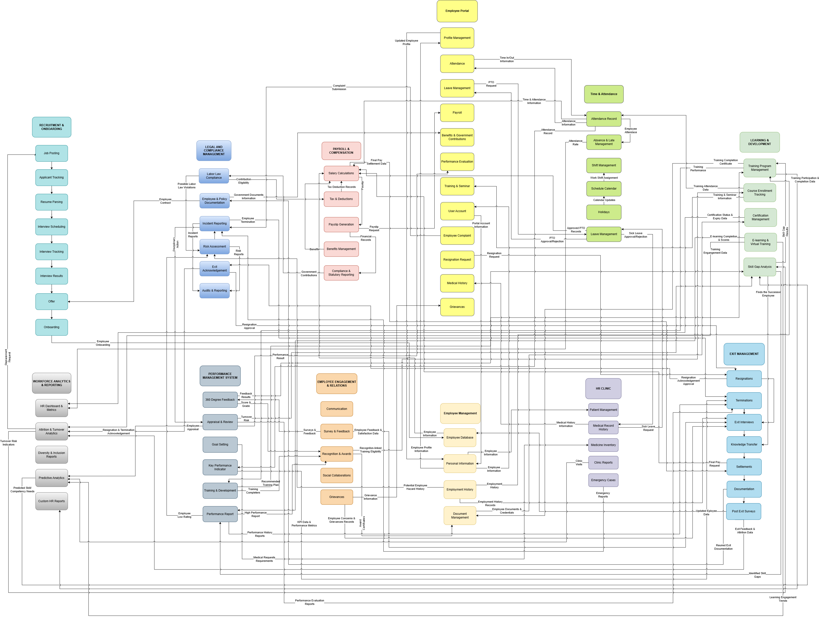
Figure 1 BPA TOP LEVEL 1
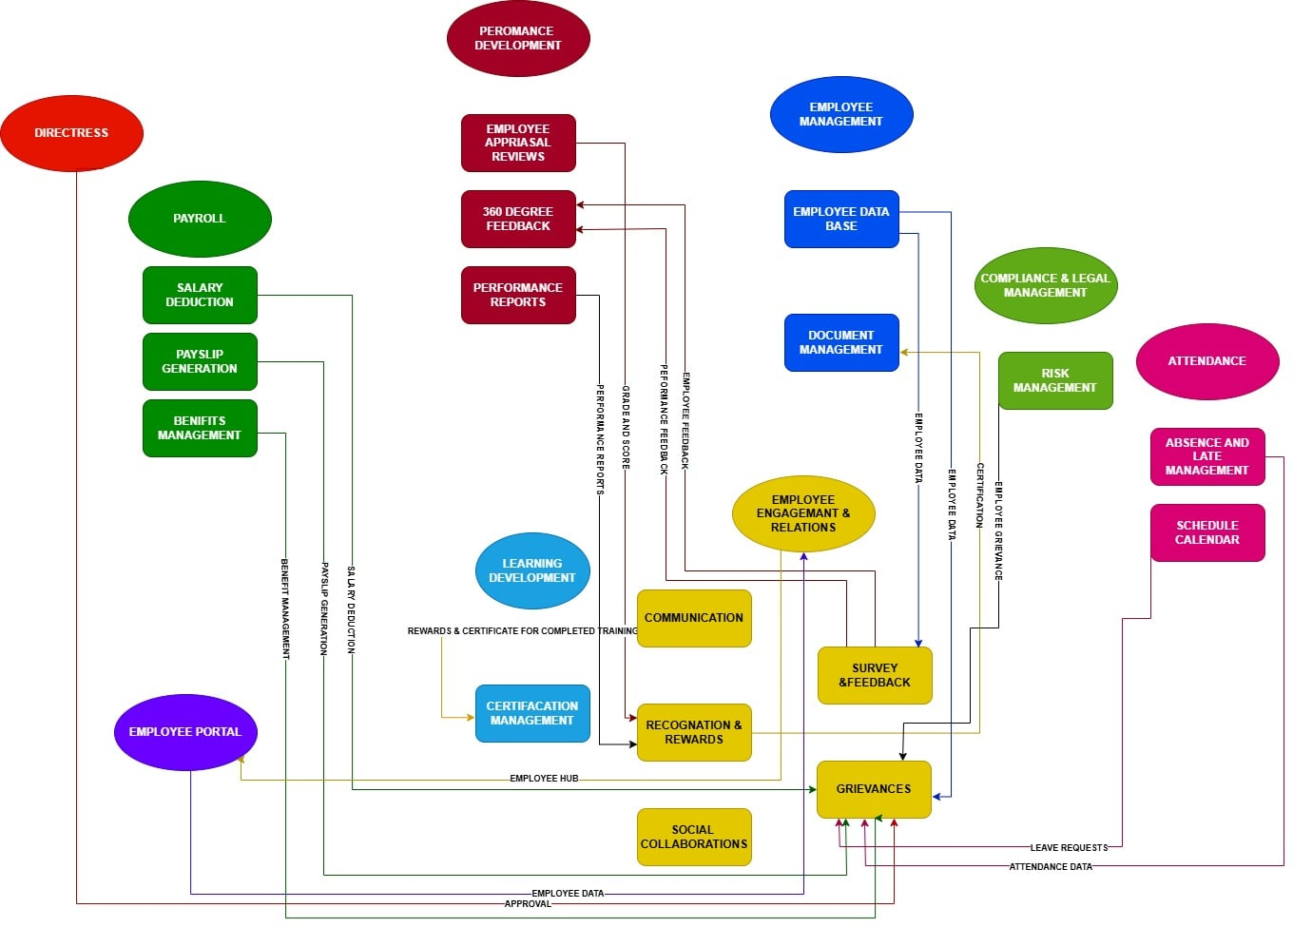Figure 2 BPA TOP LEVEL 2
MODULE | DATA | CONNECTED MODULE
Communication | Announcements, HR notifications, employee messages | Employee Portal
Communication | Employee feedback and communication updates | Performance Development
Survey & Feedback | Survey forms and responses | Employee Management
Survey & Feedback | 360-degree feedback and performance feedback | Performance Development
Recognition & Rewards | Recognition records, points, badges, awards | Performance Development
Recognition & Rewards | Rewards and certificates for completed training | Learning & Development
Grievances | Grievance records, status and updates | Employee Management
Grievances | Related payroll information | Payroll
Grievances | Related attendance information | Time & Attendance
Grievances | Grievance investigation and compliance information | Compliance & Legal Management
Social Collaborations | Posts, comments, and reactions | Employee Management
Social Collaborations | Groups, members, and project spaces | Employee Portal
Figure 3 BPA TOP LEVEL 3

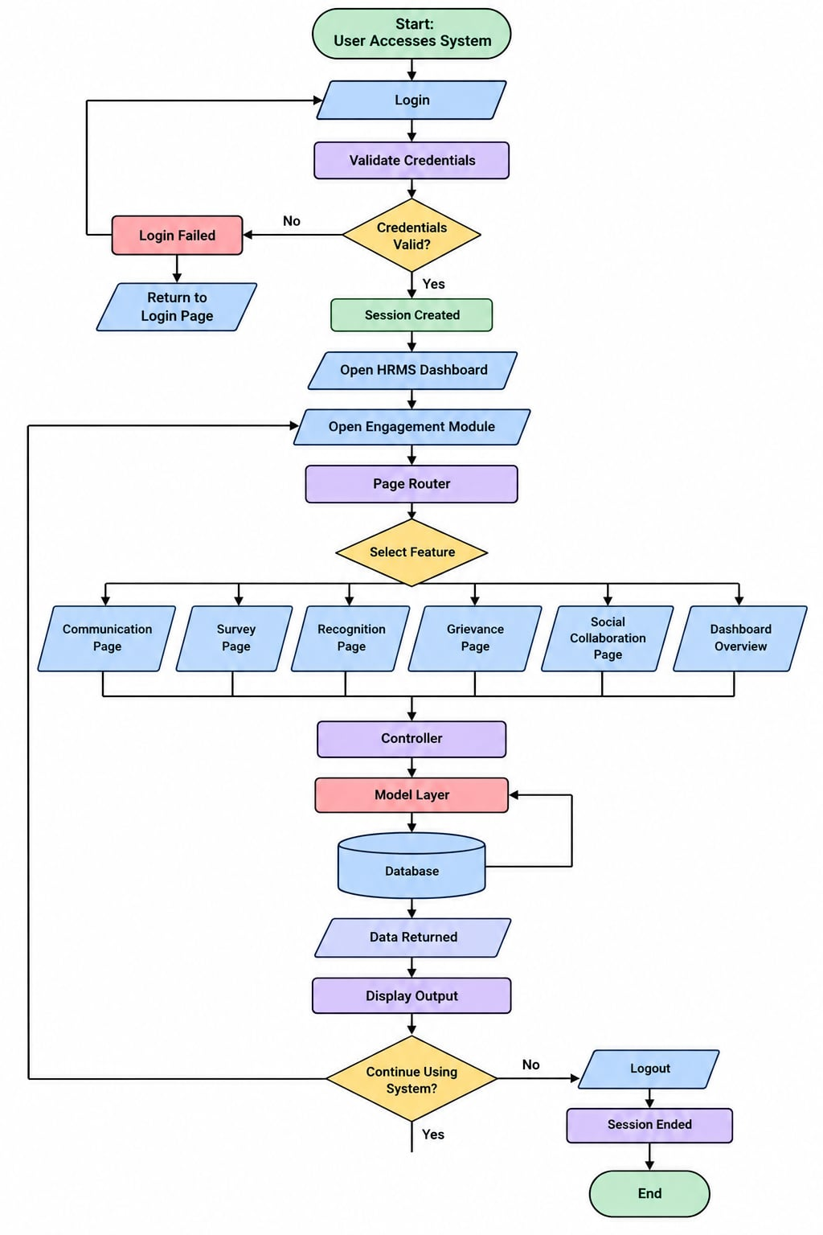
Figure System Flowchart
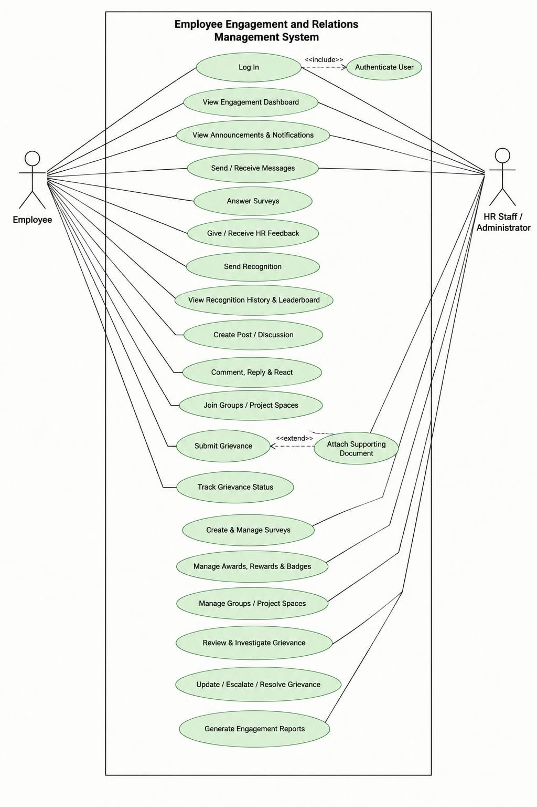
Figure User Case Diagram

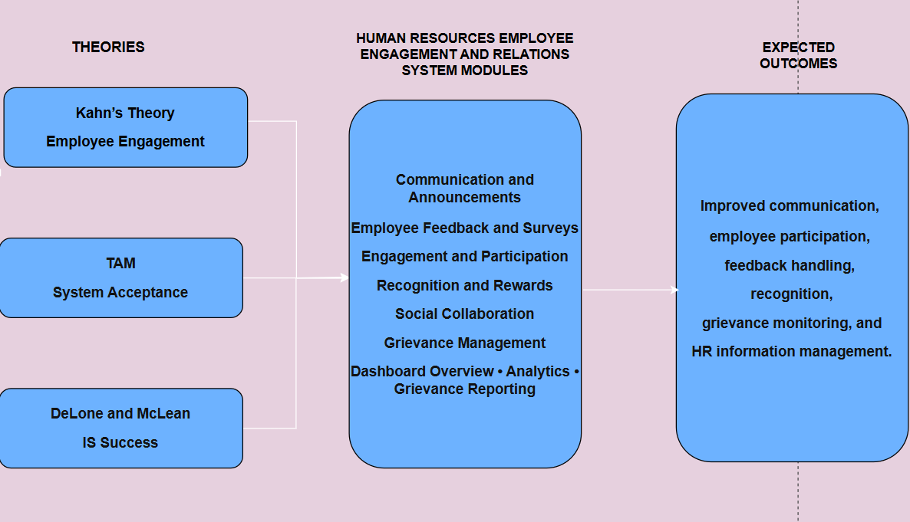
Figure Theoretical Framework

1.6 THEORETICAL FRAMEWORK
The Human Resources Employee Engagement and Relations System is supported by three theories: Kahn’s Need-Satisfaction Theory of Personal Engagement, the Technology Acceptance Model (TAM), and the DeLone and McLean Information Systems Success Model. Each theory provides a different basis for understanding the purpose, use, and evaluation of the proposed system.

Kahn’s Need-Satisfaction Theory of Personal Engagement

Kahn’s theory explains personal engagement through three psychological conditions: meaningfulness, safety, and availability. Meaningfulness refers to feeling that participation has value. Safety refers to having a work environment where individuals can express themselves without fear of negative consequences. Availability refers to having the physical, emotional, and psychological resources needed to participate.

The theory is related to the proposed system because the system provides employees with ways to communicate, give feedback, participate in surveys and activities, share ideas, receive recognition, and submit workplace concerns. These functions provide structured channels for employees to participate in activities related to their workplace experience.

In this study, Kahn’s theory supports the employee-centered purpose of the system, particularly its focus on communication, participation, feedback, recognition, and workplace concerns.

Technology Acceptance Model

The Technology Acceptance Model developed by Fred Davis explains technology acceptance through perceived usefulness and perceived ease of use. Perceived usefulness refers to whether users believe that a system can help them perform a task, while perceived ease of use refers to whether the system can be used without unnecessary difficulty.
TAM is relevant to the proposed system because both employees and authorized Human Resource personnel need to use the system for their intended activities. Employees should be able to access announcements, answer surveys, provide feedback, participate in activities, and submit workplace concerns. HR personnel and administrators should be able to manage the related records through an organized interface.

In this study, TAM provides a basis for considering whether the system is useful and easy to use for its intended users.

DeLone and McLean Information Systems Success Model

The DeLone and McLean Information Systems Success Model provides a basis for evaluating information system success through system quality, information quality, service quality, system use or intention to use, user satisfaction, and net benefits.

The model is relevant to the proposed system because the quality of the system and the information it provides can affect how users interact with it. System quality may be considered through usability, reliability, functionality, and accessibility. Information quality may be considered through the accuracy, organization, relevance, and accessibility of announcements, survey responses, feedback, recognition records, grievance records, analytics, and reports.

The model also supports the evaluation of user satisfaction, system use, and the benefits obtained from the system.

Together, the theories provide a basis for connecting employee engagement, system acceptance, and information system evaluation in the development of the Human Resources Employee Engagement and Relations System.

FIgure 2 Conceptual Framework

1.7 CONCEPTUAL FRAMEWORK

The conceptual framework presents how information moves through the Human Resources Employee Engagement and Relations System using the Input-Process-Output (IPO) Model with a feedback. It shows how employee-related information and activities enter the system, how the system processes the information through its functions, and what information and services are produced.

The framework is also connected to the three theories used in the study. Kahn’s theory supports the employee engagement perspective, TAM supports the consideration of usefulness and ease of use, and the DeLone and McLean model supports the evaluation of system quality, information quality, system use, user satisfaction, and benefits.

INPUT
The input consists of the information needed by the system to perform its selected employee engagement and relations functions.

Employee and User Information – Information needed for user accounts, authentication, authorization, and system access.

Feedback and Survey Information – Employee feedback, suggestions, comments, and survey responses.

Human Resource Announcements and Information – Human Resource announcements, notices, reminders, and other official employee-related information.

Recognition Information – Employee achievements, nominations, awards, appreciation, and recognition records.

Complaint and Grievance Information – Workplace concerns, complaints, grievances, and related supporting information submitted for Human Resource review.

Engagement Information – Participation and responses from surveys, polls, activities, comments, reactions, and other available engagement functions.

Administrative Information – Information used by authorized Human Resource personnel and administrators to manage and monitor the available employee engagement and relations activities.

PROCESS
The process describes how the system manages the information through its available functions.
Communication and Announcements – Authorized users create, manage, and publish official Human Resource information.

Surveys and Feedback – Employees answer surveys and provide feedback, suggestions, comments, and responses.

Social Interaction and Employee Participation – Employees participate in activities, discussions, comments, reactions, and other available engagement features.

Employee Recognition – The system records and manages achievements, nominations, recognition activities, awards, and appreciation.
Grievance Management – Employees submit concerns and grievances, while authorized Human Resource personnel review, update, and monitor the related records.

Survey, Feedback, and Grievance Analytics – The system organizes available survey responses, feedback, and grievance information for monitoring and review.

Grievance Reporting – The system generates organized reports from available grievance-related records.

Dashboard Overview – Authorized Human Resource personnel and administrators access relevant employee engagement and relations information through a centralized dashboard.

OUTPUT
The output represents the information and records produced by the system.

Centralized Communication and Announcements – Organized access to official Human Resource information.
Organized Survey and Feedback Records – Stored survey responses, feedback, suggestions, and comments that can be reviewed by authorized users.

Employee Participation Records – Information related to participation in surveys, polls, activities, and available interaction features.

Organized Recognition Records – Records of achievements, nominations, recognition activities, awards, and appreciation.

Managed Grievance Records – Structured records of workplace concerns and grievances, including available updates and actions.

Survey, Feedback, and Grievance Analytics – Organized analytics based on available survey, feedback, and grievance information.

Grievance Reports – Reports based specifically on available grievance-related records.
Centralized Employee Engagement and Relations Information – Organized information that supports the monitoring and management of the activities included in the project.

FEEDBACK
The feedback allows information from users and system activities to be considered for monitoring and improvement. Authorized personnel can review employee feedback, survey responses, participation information, workplace concerns, and user observations.
The feedback also connects with the theoretical framework. Employee feedback supports Kahn’s employee-centered perspective, user experience provides information related to TAM concepts such as usefulness and ease of use, and system feedback can help identify concerns related to system quality, information quality, satisfaction, use, and benefits under the DeLone and McLean model.

CHAPTER 2

RELATED LITERATURE, STUDIES, AND TECHNICAL BACKGROUND

2.1 AGILE SCRUM METHDOLOGY OVERVIEW

Figure 4 Agile Scrum Methodology
The development of the Human Resources Employee Engagement and Relations System was carried out using the Agile Scrum Methodology as its chosen approach. Through this approach, the researchers were able to break the development process down into smaller, more manageable work cycles known as Sprints. Within every Sprint, a chosen set of system requirements and functions undergoes development, testing, review, and refinement prior to moving on to the following development cycle.

Scrum encompasses various activities, including Sprint Planning, Daily Scrum, Sprint Review, and Sprint Retrospective. The purpose of Sprint Planning is to determine and rank the tasks that must be accomplished within a Sprint. Through Daily Scrum, the team is able to talk about their progress, the tasks they are currently handling, and the issues they have encountered throughout development. Sprint Review is carried out to examine the work that has been completed and to collect feedback, whereas Sprint Retrospective enables the team to recognize challenges and identify potential improvements for the upcoming Sprint.

This methodology fits the Human Resources Employee Engagement and Relations System well, given that its functions are capable of being developed and tested in stages. Among these functions are communication and announcements, surveys and feedback, engagement activities and participation, employee recognition, social collaboration, grievance management, Dashboard Overview, survey and feedback analytics, grievance analytics, and grievance reporting.

In the case of this project, the researchers tailored Agile Scrum to suit the project requirements, team structure, available resources, and development timeline. The development process proceeded through the phases of Analysis, Design, Implementation, Testing, Deployment, and Maintenance. Every phase contributed to fulfilling the system requirements within the Sprint cycles. The feedback collected during testing and review served to pinpoint errors, necessary changes, and potential improvements prior to continuing with the subsequent development activities.

Figure 5 Enterprise Architecture

2.2 ENTERPRISE ARCHITECTURE CONCEPTS

Enterprise Architecture provides a way to describe how an organization's processes, information, applications, and technology work together. In this project, it is used as a reference for describing how the Human Resource processes of Bestlink College of the Philippines – Bulacan Campus are connected to the information and technologies used by the proposed system.

Business Architecture
Business Architecture describes the activities and processes supported by the system. For this project, these include Human Resource announcements, employee feedback and surveys, engagement activities, employee participation, recognition and rewards, social interaction, and grievance management.

Data Architecture
Data Architecture describes the information stored and managed by the system. This includes employee and user information, announcements, survey responses, feedback, participation records, recognition records, comments and reactions, and grievance records.

Application Architecture
Application Architecture describes the system functions that support the identified Human Resource activities. The proposed system includes communication and announcements, surveys and feedback, engagement activities and participation, recognition and rewards, social collaboration, grievance management, Dashboard Overview, analytics, and grievance reporting.
The main users are employees and authorized Human Resource personnel or administrators. Employees use the available functions according to their access, while authorized users manage and monitor the related records.

Technology Architecture
Technology Architecture describes the technologies used to develop and support the system. The proposed system uses PHP, HTML, CSS, JavaScript, and MySQL, with XAMPP used as the local development environment.

In this project, Enterprise Architecture is used as a reference for showing the relationship between Human Resource activities, information, system functions, and technology. The project does not represent the complete Enterprise Architecture of Bestlink College of the Philippines. It focuses only on the employee engagement and relations activities included in the project scope.

2.3 MICROSERVICES ARCHITECTURE

Microservices Architecture is a way of building a system by breaking it into smaller services that work more independently. Every service handles one particular job and is able to talk to other services whenever information has to be passed along.

This idea connects to the proposed system, since that system includes several different functions, each with its own purpose. For instance, Surveys and Feedback takes care of survey responses and feedback, Recognition takes care of recognition records, and Grievance Management deals with workplace concerns and grievance records. Announcements, participation, social interaction, dashboard monitoring, analytics, and reporting are handled by the remaining functions.

Microservices usually focuses on keeping responsibilities separate, letting services be developed on their own, and having them communicate with one another. Thanks to these traits, big systems can be split more easily into smaller parts, but they also bring extra needs in communication, data management, security, deployment, and maintenance.
In this project, Microservices Architecture serves only as a technical reference. The real Human Resources Employee Engagement and Relations System is not built as a microservices system. Instead, it is made as a single web-based application that uses PHP, HTML, CSS, JavaScript, MySQL, and XAMPP. All the different functions are linked inside one application and rely on a centralized database.

2.4 DevOPS and CI/CD

DevOps is a approach of managing how a system is built, tested, released, and kept running. It lets developers work in a well-organized manner, since changes to the system can be created, reviewed, tested, and readied before people start using them. It also encourages steady improvement, because it helps developers spot and fix issues while the system is being developed.

For the planned Human Resources Employee Engagement and Relations System, the ideas behind DevOps and CI/CD can serve as a guide, helping the researchers build, test, and update the system in an organized manner. This matters because the system has many features that must work well together, including communication and announcements, employee feedback and surveys, engagement activities, recognition and rewards, social collaboration, grievance management, dashboard monitoring, analytics, and grievance reporting.

Code Development

Based on what is needed and on the information collected from the Human Resource Department, employees, and authorized administrators, the researchers will build and update the system's various features. As the project moves forward, each feature will be built and made better.
Purpose: To create and enhance the system according to the needs that were identified.
Key Activity: Writing, updating, reviewing, and organizing the code of the system.

Repository

A repository, or organized storage for the project, will be used to hold and manage the source code and other files of the project. It will help the researchers keep the project files in order and follow the changes made while developing the system.
Purpose: To keep the project files in order and handle the different versions of the system.
Key Activity: Saving code, updating files, arranging project files, and keeping records of changes made during development.

Continuous Integration (CI) and Testing

Each time the system is changed, the updated features can be reviewed and tested to confirm that they work well with the features already in place. The tests may cover employee feedback and survey submission, announcements, comments and reactions, engagement activities, recognition records, grievance submission and monitoring, dashboard information, analytics, and grievance reports.
Purpose: To catch and fix mistakes early, before they harm other parts of the system.
Key Activity: Running tests, reviewing new changes, spotting errors, and fixing the problems that are found.

Deployment

Once the system or a particular update is built and tested, it can be readied and put into the environment where it will be used. While building the system, the researchers can use XAMPP to run and test the PHP system and MySQL database on a local setup.
Purpose: To make tested system updates available in the environment they are meant for.
Key Activity: Getting the updated system files and database ready and setting up the tested system in the environment it is meant for.

Production
The production environment is the place where employees, Human Resource personnel, and authorized administrators will use the finished Human Resources Employee Engagement and Relations System.
Purpose: To give users a working system for chosen employee engagement and relations activities.
Key Activity: Using the system, handling employee engagement and relations information, and fixing problems that may come up during actual use.

Monitoring

The system will be checked on a regular basis to confirm that its features keep working as they should. The researchers or the authorized personnel in charge of keeping the system running can look into and fix any errors or problems found during testing or actual use.
Purpose: To help keep the system running well and to spot problems as early as possible.
Key Activity: Checking how the system functions, looking over errors, testing fixes, and making the improvements that are needed.
Application of DevOps and CI/CD in the Project

The DevOps and CI/CD concepts serve as a guide for the researchers in arranging the development, testing, deployment, and maintenance of the Human Resources Employee Engagement and Relations System. The researchers can put these concepts into practice by building system functions, testing changes, fixing errors, and getting tested updates ready for use.

2.4 RELEVANT STUDIES AND RESEARCH

LOCAL

"HRMS-Empowered Employee Engagement Decision Support System"

In 2025, Cabauatan, Isidro, Pereira, Valdez, Palapuz, Agravante, Boyang, and Lardizabal introduced the “HRMS-Empowered Employee Engagement Decision Support System.” The research centered on how an information system could help with employee engagement and certain Human Resource tasks. The system offered features such as messaging and announcements, surveys and feedback, employee participation, recognition, grievance handling, analytics, and reporting.

This study is a helpful guide for the current project, since a number of its features connect to the employee engagement and relations tasks that the proposed system covers. Still, the current project is made specifically for Bestlink College of the Philippines – Bulacan Campus, and its features are arranged based on what the intended users need. These cover centralized sharing of information, employee feedback and surveys, engagement activities, recognition and rewards, social collaboration, grievance handling, Dashboard Overview, analytics, and grievance reporting.
Reference: Cabauatan, C. V., Isidro, J. N. J., Pereira, J., Valdez, M. E., Palapuz, J. J., Agravante, K. A., Boyang, N. C., & Lardizabal, E. (2025). HRMS-Empowered Employee Engagement Decision Support System.
https://www.ejournals.ph/article.php?id=30786

"Digital Technologies on Personnel Engagement and Retention in Human Resource Management 4.0"

In 2025, Pinca, Lacerona, Dimaunahan, and Simangan wrote about how digital technologies are used to engage and keep employees in Human Resource Management 4.0. Their research reveals the ways digital tools help with work involving employees and with how organizations run.

The findings back the use of digital tools for communication, taking part, giving feedback, and activities that build engagement. This project takes those ideas and puts them to work in a particular information system for Bestlink College of the Philippines – Bulacan Campus. Rather than looking at digital technology across a whole organization, the proposed system turns chosen employee engagement and relations activities into functions within the system.
Reference: Pinca, J., Lacerona, R., Dimaunahan, L., & Simangan, A. N. (2025). Digital Technologies on Personnel Engagement and Retention in Human Resource Management 4.0.
https://ejournals.ph/article.php?id=32429

"Human Resource Information System with Digital Archiving"

In 2020, Argana, Sunico, and Francisco introduced a Human Resource Information System that includes Digital Archiving. This research shows how a digital system can help organize and manage Human Resource information using information technology.
It serves as a guide for keeping employee-related records in one central place. The project being proposed takes a similar approach but focuses on a smaller scope, organizing things like employee feedback, surveys, recognition, grievances, announcements, and other engagement-related information. It is not meant to take the place of a full Human Resource Information System, nor does it offer digital archiving for every Human Resource process.
Reference: Argana, E. S., Sunico, R. J. A., & Francisco, V. C. (2020). Human Resource Information System with Digital Archiving.
https://doi.org/10.53896/ijc.v39i1.1802

Foreign

"The Effect of HRIS Implementation Success on Job Involvement, Job Satisfaction and Work Engagement in SMEs"

Maamari and Osta (2021) looked at how well HRIS implementation worked and how it related to job involvement, job satisfaction, and work engagement among employees in small and medium-sized businesses. This study shows that information systems can be linked to employee-related processes and Human Resource activities.

For this project, the study gives support for using an information system to handle certain employee-related activities. The proposed system uses this idea for employee communication, feedback, recognition, engagement activities, and workplace relations at Bestlink College of the Philippines – Bulacan Campus.

Reference: Maamari, B. E., & Osta, A. (2021). The effect of HRIS implementation success on job involvement, job satisfaction and work engagement in SMEs. International Journal of Organizational Analysis, 29(5), 1269–1286. https://doi.org/10.1108/ijoa-07-2020-2298

"Adopting Human Resource Information System and Work-Related Outcomes in Emerging Market SMEs"

Shahreki and Lee (2024) examined how Human Resource Information Systems are adopted and how they relate to work-related outcomes in SMEs located in emerging markets. This study offers a foundation for looking at the ways employees and organizations rely on Human Resource information systems to carry out work-related tasks.

This project likewise employs a digital system to assist with employee communication, feedback, surveys, recognition, grievance management, engagement activities, and Human Resource monitoring. The key distinction lies in the project's setting and scope, because the proposed system is built for the employee engagement and relations activities recognized at Bestlink College of the Philippines – Bulacan Campus.

Reference: Shahreki, J., & Lee, J. Y. (2024). Adopting human resource information system and work-related outcomes in emerging market SMEs: Unified theory of acceptance and use of technology. Cross Cultural & Strategic Management, 31(1), 116–142. https://doi.org/10.1108/ccsm-09-2022-0144

"The Effects of High Performance Work Systems and Leader-Member Exchange Quality on Employee Engagement"
Oliveira and da Silva (2015) looked at how employee engagement connects to high-performance work systems and the quality of relationships between employees and leaders at a Brazilian non-profit organization. This study shows how important employees' experiences and their relationships at work are for employee engagement.

This project looks at similar topics by examining employee feedback, communication, recognition, participation, and grievance management. But that study centers on organizational relationships and work systems, whereas this proposed project builds a specific information system to support chosen employee engagement and relations activities.

Reference: Oliveira, L. B., & da Silva, F. F. R. A. (2015). The effects of high performance work systems and leader-member exchange quality on employee engagement: Evidence from a Brazilian non-profit organization.
Procedia Computer Science, 55, 1023–1030. https://doi.org/10.1016/j.procs.2015.07.092

2.6 Integration of Information System in Enterprise Environment

The Human Resources Employee Engagement and Relations System is built to help with chosen employee-related tasks at Bestlink College of the Philippines – Bulacan Campus. This system puts communication, feedback, participation, recognition, social interaction, and workplace concerns all in one place.

It offers a single, central spot for handling employee engagement and relations information. Through the right system functions, you can store and manage Human Resource announcements, notices, survey answers, feedback, engagement activities, recognition records, and workplace concerns.

Employees and authorized Human Resource staff create and use information that links these functions together. For instance, Human Resource staff can post an announcement about an employee activity. After that, employees can join the activity, complete a survey or poll, give feedback, and take part through the comments and reactions available. The information that comes out of this can be checked using the right monitoring and analytics functions.
The Grievance Management function offers a clear, organized way to submit and handle workplace concerns. Authorized Human Resource staff can look over the submitted information, update the grievance record, and keep track of its status. Records tied to grievances can also feed into the analytics and reporting functions that are available.

The Dashboard Overview gives authorized users one central view of the employee engagement and relations information that matters. This lets Human Resource staff and administrators reach the functions and records based on the permissions given to them.

The system works within its own boundaries and does not directly take the place of, or link to, institutional systems outside the project. It does not compute payroll, generate or release payroll, process biometric attendance, handle timekeeping, or connect to biometric devices. Attendance and payroll details may only be treated as supporting information when they matter to an employee concern or grievance.

This way of integrating lets the different functions operate inside one system while each keeps its own purpose. This gives the Human Resource Department one platform for the selected employee engagement and relations activities covered by the project.

CHAPTER 3: METHODOLOGY

3.1 AGILE SCRUM METHODOLOGY IN THE PROJECT

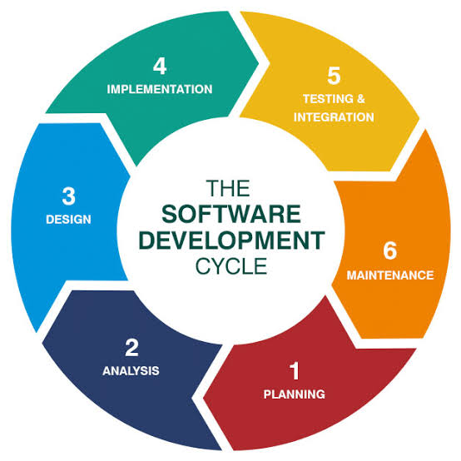
Agile is a software development approach that focuses on flexibility, collaboration, continuous improvement, and the gradual development of system functions. Scrum is a framework under Agile that organizes development activities into short and manageable cycles called Sprints. Instead of completing the entire system at one time, the researchers divided the development work into smaller tasks and functions that could be developed and reviewed step by step.
The researchers adapted the Scrum approach to the development requirements of the proposed Employee Engagement and Relations System. The development process followed six major phases: Analysis, Design, Implementation, Testing, Deployment, and Maintenance. These phases were supported by Scrum practices such as Product Backlog preparation, Sprint Planning, regular team discussions, progress monitoring, Sprint Review, and Sprint Retrospective.
Analysis Phase – The researchers identified the existing processes, problems, and requirements related to employee engagement and relations. Information was gathered through interviews, observations, and document review. The researchers examined how announcements, feedback, surveys, participation, recognition, and workplace concerns were handled.

Design Phase – The system design was developed based on the identified requirements. The researchers outlined the system's architecture, database, user interface, navigation, and process flow. The design encompassed communication and announcements, surveys and feedback, social interaction and participation, employee recognition, grievance management, dashboard monitoring, analytics, and reporting.
Implementation Phase – The system was created by the researchers using the approved design and specifications. PHP, HTML, CSS, JavaScript, and MySQL were utilized, and the local development environment was XAMPP. As the features were added to the system, they were developed gradually and verified.
Testing Phase – The developed functions were tested by the researchers to see if they met the specified requirements. System functions, database operations, user inputs and outputs, navigation, access permissions, and related function interactions are all tested. Errors found during testing were recorded, corrected, and tested again.
Deployment Phase – In preparation for deployment in the designated environment, the researchers set up the application and database for testing. They verified system connections and functionalities, allowing intended users to engage with the system and offer their feedback.

Maintenance Phase – After deployment, the researchers took into account errors, usability issues, and user feedback. Corrections and enhancements were made where needed. Any modifications needing additional evaluation could be revisited during the Analysis Phase.

The adapted Agile Scrum Framework allowed the researchers to develop the system in manageable stages and make changes based on testing and review results. This approach also helped the team coordinate tasks and monitor development progress.

3.2 ROLES AND RESPONSIBILITIES
The researchers assigned specific roles and responsibilities to each member of the development team to organize the planning, development, testing, documentation, and management of the Human Resources Employee Engagement and Relations System. Each member was given tasks based on the needs of the project. These roles helped the team work together during the different stages of system development.

Role | Team Member | Responsibilities
Scrum Master | Mendoza, Karl Ashley  karlmendoza098@gmail.com  09942159807 | Guides the team during development, organizes meetings, monitors task progress, helps address problems, and checks planned activities.
Programmer | Balansag, Geoffrey C.  balansaggeoffrey05@gmail.com  09817127679 | Develops the system based on the approved requirements and design, writes the code, creates system functions, connects the system to the database, tests the system, and fixes errors.
System Analyst | Plicerda, Lanz C.  lanzplicerda4@gmail.com  09472957607 | Studies current processes, identifies user needs and problems, gathers requirements, prepares system specifications, studies system flow, and supports system design.
Document Specialist |  | Prepares and organizes project documents, records project activities, requirements, meetings, development progress, testing results, and other project information.
Business Specialist | Mirabueno, John Carlo M.  carlomirabueno8@gmail.com  09911186173 | Identifies organizational and user needs, studies the requirements of employees and HR personnel, helps translate these needs into system requirements, and checks that system functions are aligned with HR processes.
Table 6 Team Roles and Responsibilities

3.3 SPRINT CYCLE
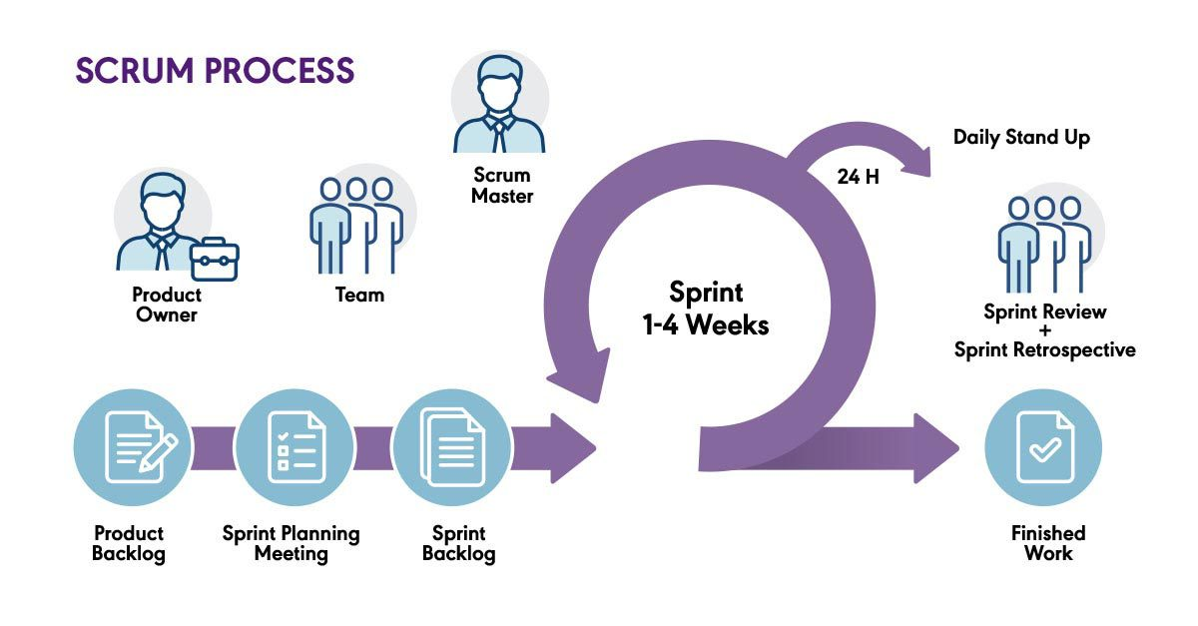
To build the system in smaller, more manageable parts. the researchers adopted a Sprint Cycle. Every Sprint concentrated on a specific set of system features. The team would plan the tasks, build the features, test what was completed, review the outcomes, and then refine things according to any problems or feedback that came up.
SPRINT | FEATURES | TASK / DEVELOPMENT | DURATION
Sprint 1 | Dashboard Overview | Create dashboard interface, design the layout for Employee Engagement and Relations information, and add summary displays. | 7 days
Sprint 2 | Communication and Announcements | Create the announcement interface and develop functions for posting and viewing announcements, notices, and updates. | 11 days
Sprint 3 | Surveys and Feedback | Create survey forms, develop survey response functions, and add feedback and suggestion submission. | 12 days
Sprint 4 | Engagement Activities and Participation | Create activity and poll interfaces and develop participation recording and monitoring. | 13 days
Sprint 5 | Employee Recognition | Create recognition forms and develop records for achievements, nominations, awards, and appreciation. | 8 days
Sprint 6 | Grievance Management | Create grievance submission forms and develop grievance monitoring, status updates, and concern management. | 6 days
Sprint 7 | Analytics | Develop survey analytics, feedback analytics, and grievance analytics. | 10 days
Sprint 8 | Grievance Reporting | Create the grievance report interface and organize grievance-related records for reporting. | 12 days
Daily Standups
TEAM MEMBER / ROLE | ACCOMPLISHMENT | TASKS | IMPEDIMENTS / CHALLENGES
Scrum Master – Mendoza, Karl Ashley | Coordinated team activities and monitored the progress of the Employee Engagement and Relations System. | Organize team meetings, monitor sprint tasks, coordinate activities, and help resolve project concerns. | Difficulty coordinating team members' schedules and monitoring task progress.
Programmer – Balansag, Geoffrey C. | Developed system functions and worked on connecting the application to the database. | Write code, develop system features, connect the application to MySQL, test functions, and fix errors. | Coding errors, database connection issues, and difficulties integrating system functions.
System Analyst – Plicerda, Lanz C. | Analyzed system requirements and prepared the system flow and specifications. | Gather and review requirements, prepare system flow and use cases, and coordinate technical requirements with the team. | Changes in requirements and the need to clarify system functions.
Business Specialist – Mirabueno, John Carlo M. | Reviewed employee and HR needs to help ensure that the system supports the required engagement and relations activities. | Identify user needs, review business requirements, and check whether system functions align with HR processes. | Limited information about some HR processes and the need to clarify user requirements.
Document Specialist – | Organized and updated project documentation based on the team's development progress. | Prepare and update chapters, tables, diagrams, meeting records, and other project documents. | Delays in receiving updates and outputs from other team members.

SCRUM ARTIFACT
SCRUM ARTIFACT / ACTIVITY | TOOLS USED | PURPOSE
Product Backlog | Google Sheets, Notes | Lists system requirements, features, and improvements.
Sprint Backlog | Google Docs | Records and tracks tasks planned for each sprint.
Sprint Planning | Google Meet, Google Sheets | Sets sprint goals and plans tasks.
Daily Scrum | Messenger | Shares progress, current tasks, and problems.
Sprint Review | Google Meet | Reviews completed work and gathers feedback.
Sprint Retrospective | Notes | Records problems and improvements for the next sprint.
Information Gathering | Google Forms | Collects user needs and system requirements.
Sprint Documentation | Google Drive | Stores meeting notes, decisions, and task progress.
Increment | Completed system files | Contains the working outputs produced during each sprint.
System Design | Draw.io, Microsoft Word | Creates system diagrams and process designs.

PRODUCT BACKLOG
Features | Name & Role | Duration
Dashboard Overview | Balansag, Geoffrey C. – Programmer | 14 days
Communication and Announcements | Balansag, Geoffrey C. – Programmer | 14 days
Surveys and Feedback | Balansag, Geoffrey C. – Programmer | 14 days
Engagement Activities and Participation | Balansag, Geoffrey C. – Programmer | 14 days
Employee Recognition | Balansag, Geoffrey C. – Programmer | 14 days
Grievance Management | Balansag, Geoffrey C. – Programmer | 14 days
Analytics | Balansag, Geoffrey C. – Programmer | 14 days
Grievance Reporting | Balansag, Geoffrey C. – Programmer | 14 days
System Integration and Database Connection | Balansag, Geoffrey C. – Programmer | Ongoing
System Testing and Error Fixing | Balansag, Geoffrey C. – Programmer | Ongoing

3.1.4 TOOLSTACK
The researchers used different tools during the planning, documentation, development, testing, and presentation of the Human Resources Employee Engagement and Relations System. These tools supported team communication, task management, documentation, system development, database management, source code management, testing, and presentation.
The main development technologies used for the system were Visual Studio Code, PHP, HTML, CSS, JavaScript, MySQL, phpMyAdmin, and XAMPP. Other tools were also used to support collaboration, documentation, project management, and system testing.
.
Tool | Purpose
Google Meet | Used for online meetings, consultations, Scrum discussions, and information-gathering sessions.
Discord | Used for team communication, updates, task discussions, and coordination.
Trello | Used to organize and monitor development tasks, backlog items, and pending work.
Google Calendar | Used to schedule meetings, consultations, deadlines, and project activities.
Google Docs | Used to write, edit, review, and update project documents.
Google Drive | Used to store and organize documents, diagrams, system files, and project materials.
Draw.io | Used to create flowcharts, system diagrams, and process diagrams.
Canva | Used to prepare presentation slides and visual materials for the defense.
Git | Used to track changes to the source code during system development.
GitHub | Used to store and manage the system source code and project repository.
Visual Studio Code | Used to write and edit PHP, HTML, CSS, and JavaScript files.
PHP | Used to develop the main system functions and processes.
HTML | Used to structure the content and pages of the system.
CSS | Used to design the layout and appearance of the system interface.
JavaScript | Used to add interactive functions and improve user interaction.
MySQL | Used to store, retrieve, organize, and manage system data.
phpMyAdmin | Used to create and manage the MySQL database, tables, fields, and records.
XAMPP | Used to run the PHP system and MySQL database during development and testing.
Web Browser | Used to access, test, and review system pages and functions.
Table 9 Toolstack

3.5 INTEGRATION APPROACH FOR INFORMATION SYSTEMS
The planned Human Resources Employee Engagement and Relations System is made to help with the employee activities of Bestlink College of the Philippines – Bulacan Campus. Instead of using separate processes, the system puts all the different employee engagement and relations activities in one place. This gives the Human Resource Department a more organized way to handle employee activities and information.
The system handles things like Human Resource announcements, employee feedback, surveys, engagement activities, recognition, social interaction, workplace concerns, and grievances. Employees can use the system to see announcements, join surveys and activities, give feedback, interact through comments and reactions, view recognition activities, and send in concerns or grievances. Authorized Human Resource staff can use the system to manage these activities and look at the information that employees provide.
The different functions of the system are linked together based on what they are for. For instance, an announcement can give information about an employee activity, and that activity lets employees take part or give their responses. Authorized staff can then look at the feedback and survey responses. Recognition activities can keep track of employee achievements and nominations, while grievance management lets workplace concerns be submitted, reviewed, and monitored.
The system also helps use employee-related information for monitoring and administrative tasks. Survey responses and feedback can help the Human Resource Department learn about employee opinions and concerns. Participation information can help track who is involved in activities, while recognition records can give information about employee achievements. Grievance records can also help authorized staff keep an eye on workplace concerns and their status.
Putting these functions together gives a more organized process for handling employee engagement and relations activities. Instead of managing announcements, feedback, recognition, and concerns in different ways, the system gives one place where authorized users can manage and review these activities. This can also make employee-related information easier to find and follow when it is needed.
The planned system only covers selected employee engagement and relations activities. It does not take the place of other Human Resource systems or handle payroll computation, payroll generation and disbursement, biometric attendance processing, timekeeping, or biometric device integration. Attendance and payroll information may only be used as supporting information when it relates to reviewing an employee concern or grievance.
This integrated setup lets the different parts of the Human Resources Employee Engagement and Relations System work as one to support communication, feedback, participation, recognition, and workplace concerns. With this approach, the Human Resource Department gets a single, organized system for handling the employee engagement and relations activities that fall within the project's scope.

3.6 Monolithic Architecture
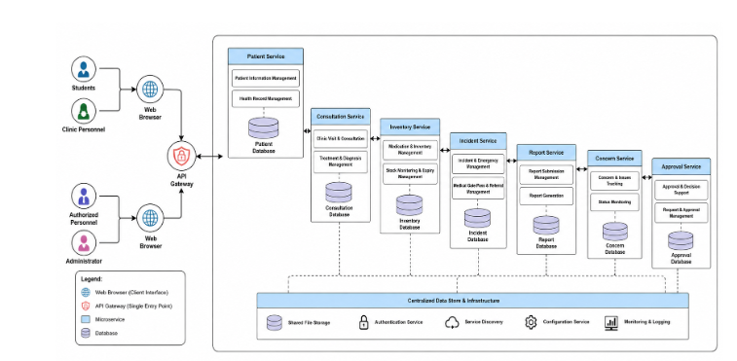
The Human Resources Employee Engagement and Relations System is built using a monolithic architecture, meaning all of its different functions are created and linked together as a single application. The system keeps its functions together instead of splitting them into separate services. Rather than being divided, the various parts of the system operate as one within a single centralized application.
A monolithic architecture fits the proposed system well, since the project is meant to be one system that handles employee engagement and relations activities. The functions are linked to one another and can exchange related information inside the same system. Because of this, authorized users can reach the functions they need without opening separate applications.
The system offers functions like communication and announcements, employee feedback and surveys, engagement activities and participation, recognition and rewards, social collaboration, grievance management, dashboard monitoring, analytics, and grievance reporting. Even though every function serves its own purpose, all of them belong to the same system and are linked together to support the organization's employee engagement and relations activities.
The system also relies on a centralized database, which stores the information created and managed by the various functions. For instance, authorized users can record and review survey responses and feedback, recognition records can be managed, and grievance records can be monitored and used for reporting. Keeping these records in a single system helps arrange information and makes it simpler for authorized users to reach related records.
The use of a monolithic architecture also gives the researchers a simpler structure while developing the system. Because the system's functions belong to one application, the researchers can manage, test, and update the system as a single project. This suits the scope of the proposed system and the needs of the organization.

3.7 INTRODUCTION TO TOGAF AND THE FOUR ARCHITECTURE DOMAINS

The Open Group Architecture Framework (TOGAF) is a framework used to organize and describe information systems and technology architecture. In this project, TOGAF is used only as a reference for describing the different areas of the Human Resources Employee Engagement and Relations System.
Business Architecture
Business Architecture describes the organizational activities supported by the system. For this project, these activities include communication and announcements, employee feedback and surveys, engagement activities and participation, recognition and rewards, social interaction, and grievance management.
Data Architecture
Data Architecture describes the information managed by the system. This includes employee and user information, announcements, survey responses, feedback, participation records, recognition records, comments and reactions, and grievance records.
Application Architecture
Application Architecture describes the system functions that support the identified activities. The proposed system includes communication and announcements, surveys and feedback, engagement activities and participation, recognition and rewards, social collaboration, grievance management, Dashboard Overview, analytics, and grievance reporting.
The main users are employees and authorized Human Resource personnel or administrators. Each user accesses functions based on assigned roles and permissions.
Technology Architecture
Technology Architecture explains which technologies are used to build and maintain the system. The project relies on PHP, HTML, CSS, JavaScript, MySQL, phpMyAdmin, XAMPP, and a web browser. These technologies help build the system, manage its database, run it, and test it.
The four domains link to one another. Business Architecture points out the activities that must be supported. Data Architecture points out the information required for those activities. Application Architecture points out the system functions that handle the information, and Technology Architecture points out the technologies that support the application.

